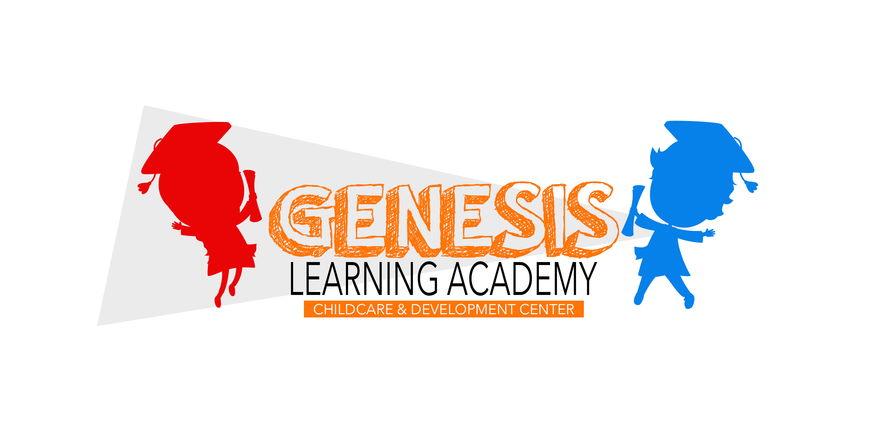

Family Registration

910-568-5685 | www.GLAcademyNC.com

Child Information
Registration Date:

1st Child
Last Name |  |  | First Name |  | M.I. | Nickname
Entering grade | [ ] Male [ ] Female  [ ] Prefer not to specify | Birth Date |  | Birth City/State  City: State: |  |  | Social Security #
Existing medical conditions, medications and/or special attention your child may require
Allergies
Pediatrician’s Name | Phone | Address

Photos: May we take and maintain a photo of your child for security purposes?
[ ] Yes [ ] No

2nd Child
Last Name |  |  | First Name |  | M.I. | Nickname
Entering grade | [ ] Male [ ] Female  [ ] Prefer not to specify | Birth Date |  | Birth City/State  City: State: |  |  | Social Security #
Existing medical conditions, medications and/or special attention your child may require Allergies
Pediatrician’s Name | Phone | Address

Photos: May we take and maintain a photo of your child for security purposes?
[ ] Yes [ ] No

3rd Child
Last Name |  |  | First Name |  | M.I. | Nickname
Entering grade | [ ] Male [ ] Female [ ] Prefer not to specify | Birth Date |  | Birth City/State  City: State: |  |  | Social Security #
Existing medical conditions, medications and/or special attention your child may require Allergies
Pediatrician’s Name | Phone | Address

Photos: May we take and maintain a photo of your child for security purposes?
[ ] Yes [ ] No

Primary Guardian Information
Name(s) of person(s) with whom child is living

1st Primary Guardian
Last Name |  | First Name |  |  |  |  | M.I. | Relationship to Child
Email Address |  |  | Work Phone |  |  |  |  | Cell Phone
Occupation | Employer |  |  | Work Address |  |  |  |  | Work Hours
2nd Primary Guardian
Last Name |  | First Name |  |  |  |  | M.I. | Relationship to Child
Email Address |  |  | Work Phone |  |  |  |  | Cell Phone
Occupation | Employer |  |  | Work Address |  |  |  |  | Work Hours
Which Guardian Should be Called First? |  |  | Home Phone |  |  |  |  | Preferred language for written communication:
Home Resident Street Address |  |  |  |  | Apt # | City |  |  |  | Zip Code
Mailing Address (if diﬀerent than above) |  |  |  |  | Apt # | City |  |  |  | Zip Code

Second Guardian Information
Non-primary custodial parent

1st Non-primary Guardian
Last Name | First Name |  |  | M.I. |  | Relationship to Child
Email Address |  | Work Phone |  |  |  | Cell Phone
2nd Non-primary Guardian
Last Name | First Name |  |  | M.I. |  | Relationship to Child
Email Address |  | Work Phone |  |  |  | Cell Phone
Which Guardian Should be Called First? |  | Home Phone |  |  |  | Should mailings be sent to this household also? [ ] Yes [ ] No
Second Household Mailing Address |  | Apt # | City |  | State |  | Zip Code

Additional Comments & Information:

Emergency Contacts and Authorized Pickups

1st Contact/Pickup
Last Name |  | First Name |  | Relationship to Child
Home Phone | Cell Phone |  | [ ] Able to pick up all children in the family  [ ] Not able to pick up the following children:
2nd Contact/Pickup
Last Name |  | First Name |  | Relationship to Child
Home Phone | Cell Phone |  | [ ] Able to pick up all children in the family  [ ] Not able to pick up the following children:
3rd Contact/Pickup
Last Name |  | First Name |  | Relationship to Child
Home Phone | Cell Phone |  | [ ] Able to pick up all children in the family  [ ] Not able to pick up the following children:
In the case of an emergency, is there any particular hospital you would prefer that Emergency Services transport your child to? Yes/No (circle one) if yes, please provide:____________________________________

Additional Comments and Information

Is there is any other information that that would be helpful to our management and teaching staﬀ?

Signature

Parent / Guardian Signature Date

REGISTRATION AGREEMENT

I represent that I am the parent, legal guardian, or authorized individual of each child on this registration form and that I, on behalf of myself, my spouse, listed child(ren), or the parents/legal guardians of each listed child(ren) on this Agreement Form, enter into this Agreement Form (Agreement) with Genesis Learning Academy. From this moment forward each designated child on the Agreement form will be referred to as “my Child”, I will be represented as the “parent”, and Genesis Learning Academy will be referred to as “GLA”.

Sick Policy: Regulations Concerning Sick Children
According to the N.C. Dept. of Health & Human Services, Division of Child Development, we are unable to accept a child with a diagnosed communicable disease (measles, mumps. chickenpox, etc.) or obvious acute illness. Therefore, please do not send your child to the Center when he/she is sick or has signs of a possible contagious disease. If your child has a communicable disease, please keep him/her home until the symptoms have subsided and the child feels well enough participate in Center activities. To help prevent the spread of colds, illnesses, and disease please wash your hands and your child’s hands upon arrival and departure.
In order for the staff to administer medication it must be prescribed by a doctor unless it is an over-the counter medication, which can be given only as recommended by the label. Please help us by:
A. Signing and dating a medical consent form, which can be picked up from the class.
B. Making sure all medication is in the original container and the date, child’s name, doctor’s name, and the dosage plainly stated is present on prescribed medications.
If a child has a temperature of 101 degrees or greater, diarrhea, contagious illness, or an injury occurs during the day, the parent or next of kin will be contacted immediately. If there is a serious injury and/or medical problem, the parent and/or the local rescue squad may be contacted for assistance. If the nature of the illness is not life threatening, the director will transport the child to the hospital or local physician.
If this action is taken parents/guardians will be contacted immediately.
*All staff members are first aid and CPR certified.

Future Visits
The Registration Form, including this Agreement page, will be kept on file with GLA and constitutes binding obligations for any future visits my Child may make to GLA. GLA reserves the right to refuse admission to any child for any reason and without liability.

Payment
Payments for GLA services are due upon each pickup and can be made in cash, check, or credit/debit card. The fee is calculated by multiplying the time elapsed from check-in to check-out by the rates posted at the time of the visit, and adding any other additional costs that have incurred, such as, late fees, meals, diapers, and retail items. If a package was purchased, time used will be posted against this package and any overage is to be paid in full at time of check-out with the same calculation as above. GLA reserves the right to refuse payment by check and charges a fee for any returned checks.

Discipline & Behavior Management Policy
The guidelines for discipline at GLA are to foster and teach children to be independent self-monitors of their behavior. This will be achieved through behavior guidelines provided by teachers and staff.
Children attending Genesis Learning Academy will not be subjected to any form of corporal punishment by the Director or any other staff of the facility. The definition of “staff,” includes: any regular or substitute caregivers, volunteers, cooks, secretaries, janitors, vehicle drivers or any other individual who might come into contact with the children while providing services for GLA.

GLA instructors and other staff will provide Verbal Guidance by:
- Speaking kindly to children.
- Providing positive verbal praise when interacting with children.
- Giving clear instructions.
- Avoid making comparisons between children.
- Giving positive directions and suggestions.
- Modeling Christian values-as we are a religious facility, and our Foundational principles are of the Christian Faith.
- Promoting positive self-esteem.

GLA instructors and staff will provide Behavioral Guidance by:
- Supervising children for all activities (indoor, outdoor, and field trips)
- Planning developmentally appropriate classroom activities.
- Ensuring that children know the consequences for inappropriate behavior.
- Providing consistency in discipline practices.
- Ensuring that teachers and staff will be positive role models.
- Giving children choices.
- Knowing and understanding the mental and emotional needs of the children.
- Using “Time Out” immediately following physical aggression, hitting with objects, kicking, or biting. (You received a copy of the Disciplinary Policy and an explanation of time out with your application packet).

GLA complies with General Statues of the State of North Carolina; which are:
- No child will be handled roughly in any way including shaking, pushing, shoving, pinching, slapping, biting, kicking, or spanking.
- No child shall ever be disciplined for not sleeping during rest period.
- No child shall ever be placed in a locked room, closet or box.
- No child shall be disciplined for toileting accidents or any other accidents.
- No child shall be delegated to providing discipline of another child.
- Foods shall not be withheld as a means of discipline.

Reporting Child Abuse and Neglect
We understand the importance of family unity, however if a time arrives where upon any symptoms of suspected child abuse or neglect by a staff member or parent/guardian are brought to our attention, we are required by law to report it to the Cumberland County Department of Social Services. If when picking your child up from GLA the person responsible for pickup is under the influence of a controlled substance that causes our staff to suspect possible danger to the life of that individual or child leaving our center, we will NOT release the child. The parent can opt to cooperate and allow our staff to contact another individual on the pick up list or allow the authorities to resolve the matter. This Center will abide by this law.

Photos/Videos
We take pictures and videos of children on a regular basis as a way of documenting your child’s learning process. These pictures are used in your child’s portfolio and as materials for Marketing and advertising GLA. Pictures are always used and shared with respect. By signing the last page of this handbook, you will be giving GLA permission to use your child’s image whenever necessary. If you do not wish to have your child’s pictures and/or videos used for these purposes please note your exception on the same page.

Safety/Indemnity.
I agree that GLA may take action, which it considers prudent to protect the safety of my Child, and other children visiting GLA. I further agree that I hereby waive and release all rights, causes of action and claims against Genesis Learning Academy, its Officers, Directors, Agents, and Employees and all of its affiliates, for any loss, expense, damage or injury suffered by my Child or my property, including the possible negligence of GLA, but excluding gross negligence and intentional misconduct, during the time my Child visited GLA. I further agree that I hold GLA harmless from all actions, claims or liability, including attorney fees and court costs, directly or indirectly caused by my Child or resulting from any inaccuracy or omission made by me in completing the Registration Form.

Additional Requirements.
As a condition to my use of GLA, I agree that I have accurately completed and signed the Registration Form and that GLA will rely on this information while caring for my Child. I agree that I will pay all costs arising out of any action relating to this Agreement or the Registration Form for collection purposes or otherwise.
By signing this release I appoint GLA to provide temporary childcare for my Child at my own risk. I have been given an opportunity to ask questions and obtain answers to my satisfaction regarding all aspects of GLA. I am not relying on any promises or statements made by GLA, other than those written in the documents supplied to me by GLA. I understand that this release will be kept on file with GLA and will continue in effect for this and any future visits my Child may make to GLA.

I HAVE READ THE AGREEMENT CAREFULLY AND FULLY UNDERSTAND THE CONTENT AND CONSEQUENCES OF THIS AGREEMENT BEFORE SIGNING

______________________________________________________ _______________________________________________________
Signature & Date of parent/legal guardian or authorized individual Signature & Date of FTKP Authorized Representative

IMMUNIZATION AGREEMENT
For the safety of others at Genesis Learning Academy, all staff and children must be up to date on their immunizations. For your convenience, we will still provide service to your child as long as they are current on their vaccinations and the below is complete:

• A signed Registration Form with the Immunization section completed
• A signed Immunization Agreement form stating that you will provide to us a copy of this information within 30 days, otherwise your child will not be accepted until received.

I acknowledge that I will need to provide Genesis Learning Academy with my child(s) immunization(s) record within 30 days of registration. If I fail to do so, GLA will not provide service until this has been received.

CHILD 1: CHILD 2: CHILD 3:
Name_________________________________ Name__________________________________ Name___________________________
Age___________________________________ Age__________________________________ Age___________________________

Signed_______________________________________ Date_______________________
Printed Name_________________________________

We sincerely appreciate your understanding and patience in this manner. Your child’s health and safety is our number one concern. If you have any questions or concerns, please contact one of our management staff. Thank you!

